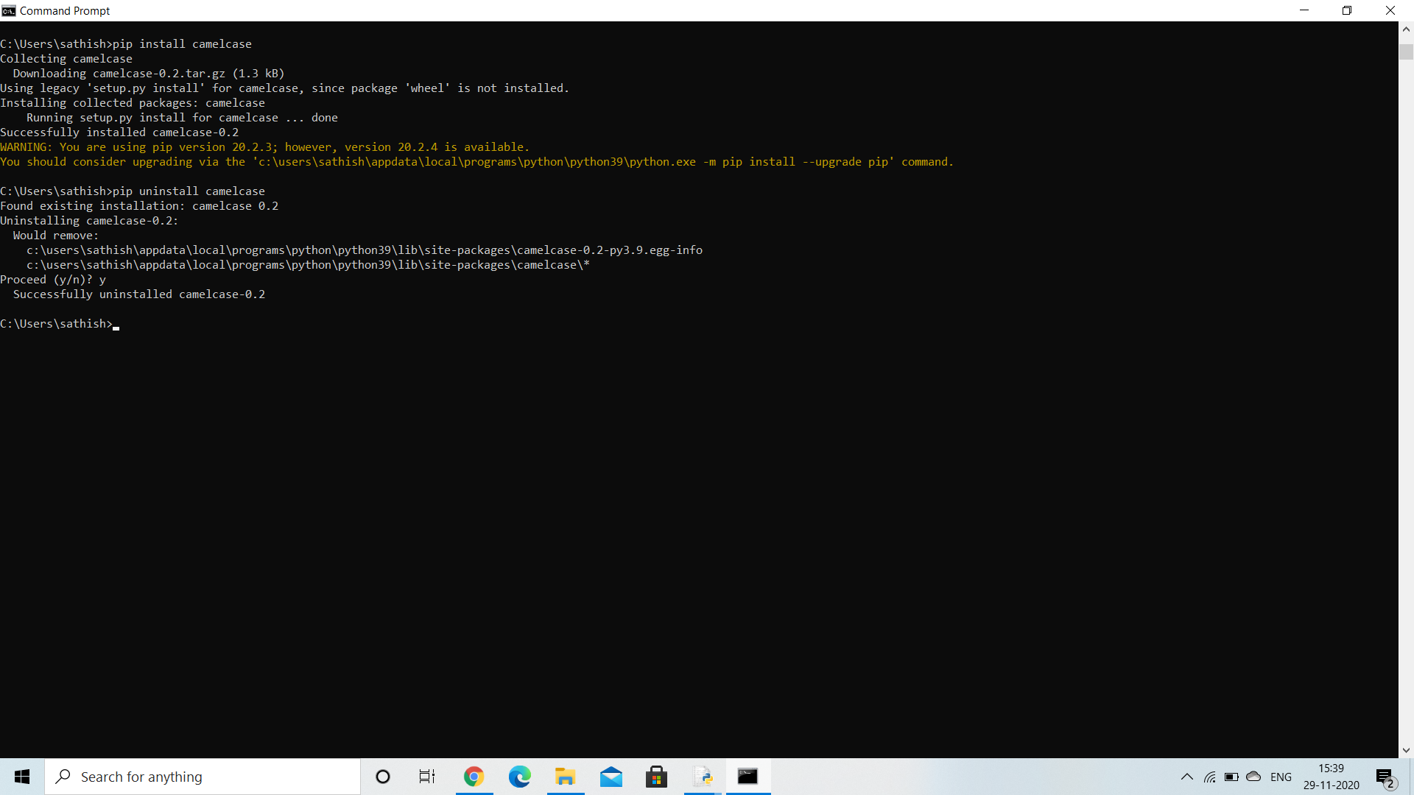

**INSTALLING AND UNINSTALLING A PACKAGE USING PIP**